Linux Basics
- Linux is free and open source operating system created by Linus Trovalds in 1991
Command | Description
apt-get update | Update all packages on linux
apt-get upgrade | Replace old packages with the newest packages
ls | List the directory contents on the current working directory. You can use switches beside the command, for example: ls -lah
ifconfig | Get the interface configuration, show the configuration of the network interface, this display information about: IP address, Ethernet, Netmask, Broadcast, …
pwd | Print the current working directory
man | Show the manually page of the command, for example: man ls
ctrl + l | Clear the screen
clear | Clear the screen
locate | Used to search about directories, files. For example: locate rockyou.txt
find | Used to search about files.  find /path/to/search/ -name file_name  for example: find /home/ -name pass.txt
curl | Used to deal with all protocols, allow you to download images, used to transfer a URL, for example: curl https://www.google.com
wget | Transfer a URL, used to download the files, for example:  wget https://www.google.com
touch | Used to make files, for example: touch main.py
> | Used to replace the content of the files, for example: echo “hi” > text.txt
>> | Used to append at the end of the file, for example: echo “hi” >> text.txt  Example, ls -lah > ls.txt
| | Called pipe, is used in the command line to pass the output of one command as input to another. for example: ls -l | grep ".txt"  ifconfig -I “inet” → this will show only lines that contains inet
; | Called semicolon, used to execute more than one command at the same line.  For example: ls; pwd; touch index.html;
cut | Used to extract specific sections from lines of text. Syntax: cut [options] [file]  -b: select bytes  -c: select characters  -d: specify a delimiter (used with -f)  -f: select fields (column) usually with a delimiter  Example: echo "HelloWorld" | cut -c1-5  Example: ifconfig | grep -i 'inet' | cut -d ':' -f 2
&& | Run more than one command at the same line, for example: ls && pwd;
& | Used to run the command on the background, allowing you to use the terminal without waiting for the command to finish. For example: ls&pwd  This means that run ls on the background, pwd on the foreground  nmap 192.168.1.0/24 & ls
head | Show the top lines of the file, for example head test.txt  head -n 2 test.txt → show first 2 lines on the file
tail | Show the last lines of the file, for example: tail text.txt  tail -n 2 test.txt → show last 2 lines on the file
grep | Used for searching text using patterns (regular expressions). It is also used to filter output or files for lines that match a specific string or pattern  Examples:  grep "hello" file.txt → Search for a string in a file  grep -i "hello" file.txt → Ignore case while searching  grep -v "hello" file.txt → show lines that don't match  grep -n "hello" file.txt → Show line numbers  grep "^h.*o$" file.txt → Use regular expressions  ps aux | grep firefox → To search output of another command
tee | Reads from standard input and output and writes to both standard output  ls -l | tee output.txt → Save output to a file and also display it  echo "New line" | tee -a log.txt → Send output to multiple files
ps | Show information about active processes. It is short for process status  ps -ef → Show detailed information
df | Used to report file system disk space usage.  df -h → show information in a human readable  -h → human readable  -T → show file system type
top | Display real time information about file system’s processes, resources, usage, and overall system performance.  top
htop | Is an interactive process viewer, and alternative to the top command. It provides a more user-friendly, colorful interface for monitoring system resources and managing processes.  htop

File Permissions
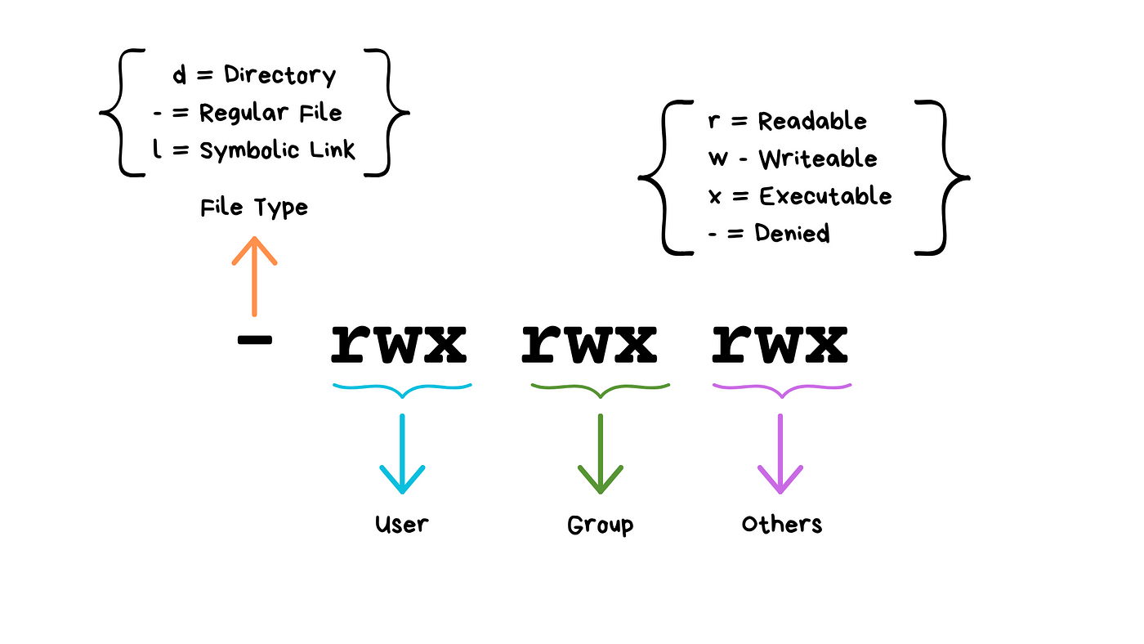
- change the owner on a specific file
chown root:zigo /etc/shadow [zigo: this is the user that allow to use the file]
- change the permissions of the file:
chmod 777 file_name
777 can be any permissions like the following:
